Courthouse - Fillmore  50 South Main  Fillmore, UT 84631-5504  Fax: (435) 743-8019  Commission Secretary:  (435) 743-6223  Fax: (435) 743-6923 |  | Millard County  www.millardcounty.org
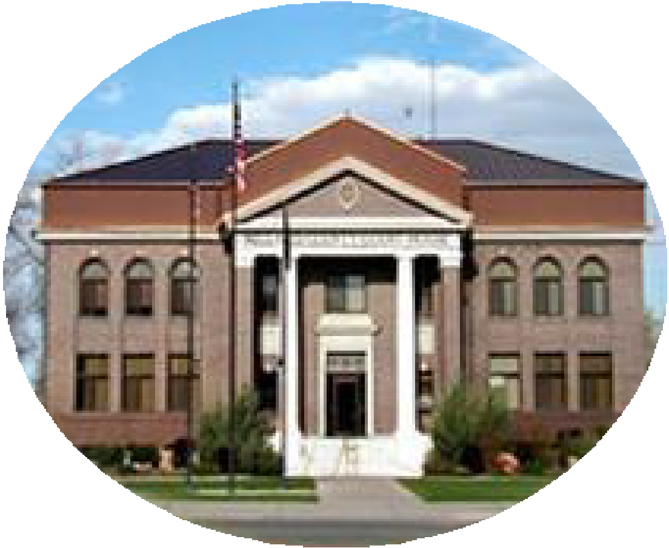
Satellite Offices – Delta
71 South 200 West ◦ P.O. Box 854
Delta, UT 84624
Phone: (435) 864-1400
Fax: (435) 864-1404

11/5/2024/24
Millard County is accepting applications for the position of regular full-time Landfill Operator I. Must possess a current Utah Class A CDL (Commercial Drivers License) and MEC (Medical Examiner’s Certificate).

Must be able to pass ICC physical. Operates front load compactor, grader, compactor, scraper, backhoe, dozer or related heavy equipment utilized in the moving, covering and compacting of waste deposited into county landfill; maintains road allowing easy access in and out of landfill sites. May be required, as needed, to operate trucks, large roll off metal bins, hydraulic lifts, and mechanically driven tarp covers in collecting, transporting, and depositing refuse in county sanitary landfills. Performs all assignments made by supervisor. Has tolerance for working in extreme weather. Preference may be given to applicants with heavy equipment operator experience. Must be 21 years of age or older to apply.

Application packets and a complete job description are available at www.millardcounty.org. Application with a résumé may be emailed to jnielson@co.millard.ut.us or taken to the Millard County Clerks Office at 765 UT-99, Fillmore, UT 84631 by November 19th by 5:00pm. If you have any questions about the position feel free to contact me at (435) 406 6258
Millard County is an Equal Opportunity Employer

