Courthouse - Fillmore  50 South Main  Fillmore, UT 84631-5504  Fax: (435) 743-8019  Commission Secretary:  (435) 743-6223  Fax: (435) 743-6923 |  | 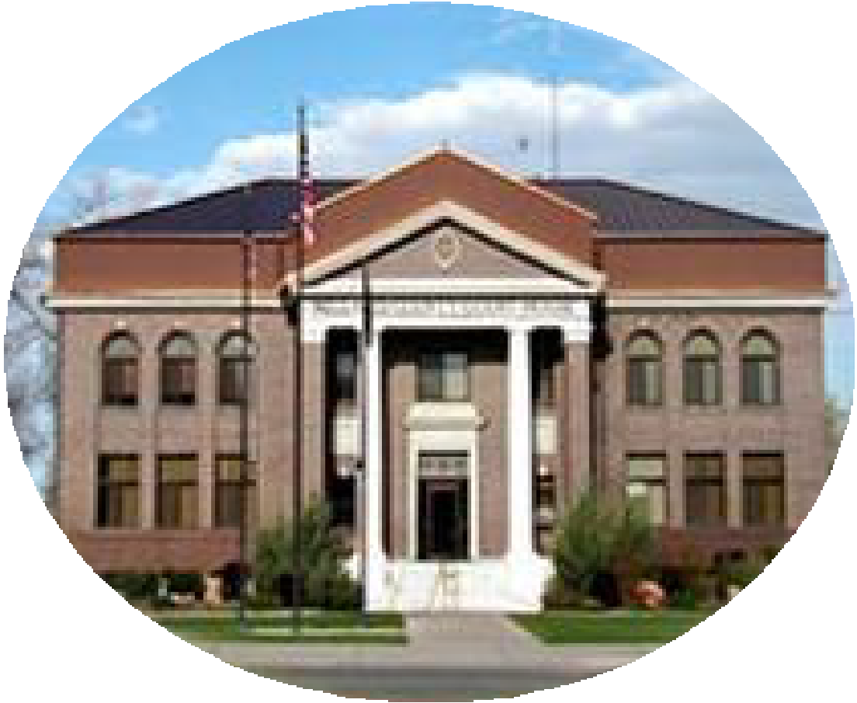  Millard County  www.millardcounty.org
Public Safety Building
765 South HWY, 99
Fillmore, UT 84631

Satellite Offices – Delta
71 South 200 West ◦ P.O. Box 854
Delta, UT 84624
Phone: (435) 864-1400
Fax: (435) 864-1404

Job Announcement
10/28/2024

The Millard County Road Department has an opening for a full-time Heavy Equipment Mechanic. The position of Mechanic will manage the day-to-day mechanical needs and operations of the Millard County fleet of vehicles and equipment and perform skilled tasks related to the maintenance, repair, and rebuilding of county mechanized diesel and gas equipment. Duties may be performed in county facilities or in the field.

Applicants must have a current Utah CDL and a minimum of Six (6) years of experience in major repair of a
variety of gas and diesel vehicles. Preference will be given to candidates who are ASE certified.

Starting wage will be negotiated based on experience and skill level and will follow the Millard County Step & Grade recommendation.

Applications and a full job description can be found at millardcounty.org. Qualified candidates may submit an application, resume, and a copy of applicants driving record (available at any Utah Drivers License Office) to the Millard County Clerks Office at 765 S HWY 99, Ste #6 Fillmore or by email to JNielson@co.millard.ut.us This posting will remain open until filled

Millard County is an Equal Opportunity Employer

