Courthouse - Fillmore  50 South Main  Fillmore, UT 84631-5504  Fax: (435) 743-8019  Commission Secretary:  (435) 743-6223  Fax: (435) 743-6923 |  | Millard County  www.millardcounty.org
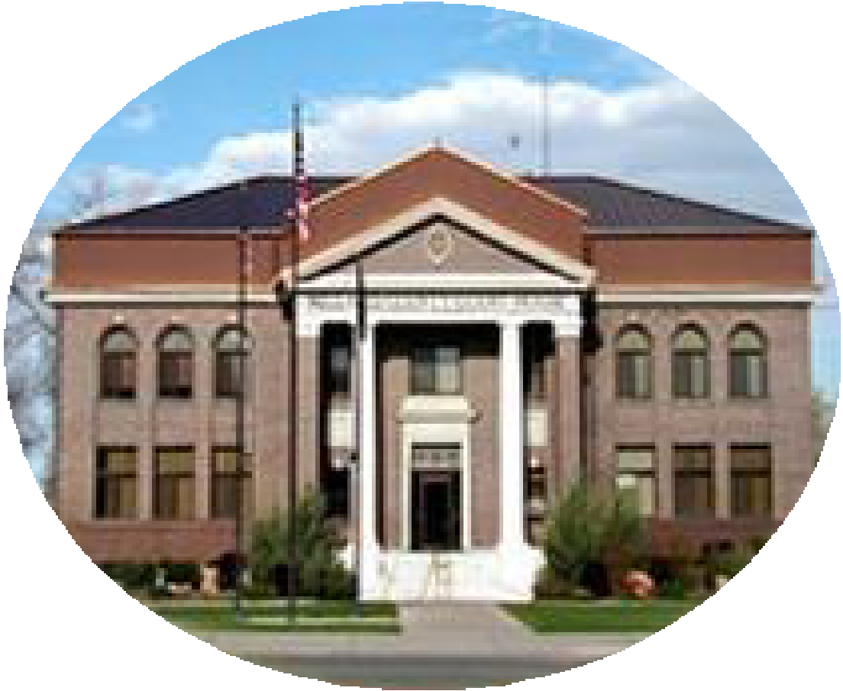
Satellite Offices – Delta
71 South 200 West ◦ P.O. Box 854
Delta, UT 84624
Phone: (435) 864-1400
Fax: (435) 864-1404

May 30, 2024

Job Announcement

Millard County Road Department is currently accepting applications for a full time heavy equipment operator. Applicant must have a current Utah CDL (Commercial Drivers License) and a current ICC physical card. Candidates should have experience operating heavy equipment.

This position is responsible for maintenance on assigned equipment and all other work assigned and directed by the Road Supervisor. Employees may be required to lift items not exceeding 100 pounds and have tolerance for working in extreme weather conditions. Applicant must be able to work well with fellow employees.

Hourly wage will depend on qualifications and experience following the county step and grade pay schedule. Benefits are in accordance with the Millard County Benefit package approved by the Millard County Commission. Applications and a full job description can be found online at www.millardcounty.org. A copy of applicants driving record (available at any Utah Drivers License Office) must be attached to the application when submitted. Applications will not be considered without the required information.

Applications and driving record can be submitted by emailing jnielson@co.millard.ut.us or can be brought to the County Delta Offices at 71 S. 200 W Delta or the Millard County Clerk’s Office at 765 S HWY 99 Fillmore. Applications and driving records must be received by 5:00 pm on June 12, 2024.

Millard County is an Equal Opportunity Employer

